Clients Updating Their Payment Method
Your clients can update the payment method on their active recurring subscriptions to avoid their subscription being cancelled. This is useful when they know their existing payment method is due to expire soon. If their payment fails, they need to create a new subscription using a valid payment method.
Important:
- Update payment method is only available for active, online recurring subscriptions.
- Your clients can currently only update their payment method on desktop.
- Clients can only update their payment method to a credit card - they currently cannot update their payment method to Paypal.
- Your clients need to update the payment method on all their subscriptions separately (changes to one subscription do not affect all subscriptions).
- Update payment method is not yet available to everyone, however, your clients can update their payment method through Paypal or Stripe where relevant.

How your clients can update their payment method
Clients update the payment method on an active recurring subscription by logging in to your site and going to the My Subscriptions section of the Members Area.
They then select the relevant subscription to expand it. The current payment method appears under the subscription details in the My Subscriptions section.

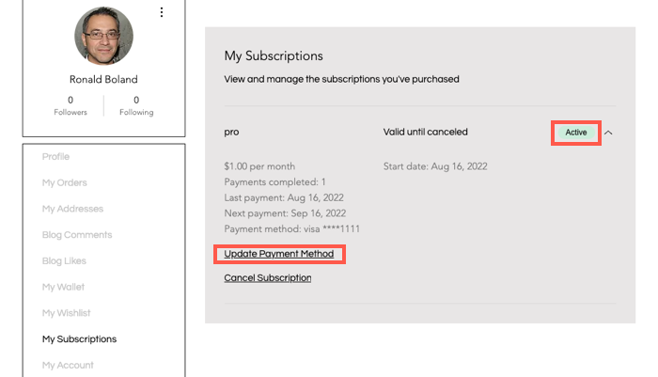

Clients can select a previously saved payment method or enter new, valid payment details as required.
When entering new payment method details, your clients also enter billing details such as the relevant name and address connected to the payment method.
